Requirements/Design Specification

**DWCORE Data for Capture Existing Industrial**

Revision History

|  |  |  |  |
| --- | --- | --- | --- |
| **Date** | **Revision** | **Description** | **Author** |
| 11/03/2014 | 1.0 | Initial Version with Business Requirements | Rich Simon |
| 12/11/2014 | 1.1 | Initial Version with Technical Requirements | Doug Bloebaum |
| 2/9/2015 | 1.2 | Merged Business and Technical Documents | Roger |
| 2/16/2015 | 1.3 | Added flow charts | Roger |
| 3/26/2015 | 1.4 | Addressed Container, STR tables and Service Criteria (Insert C) within section 3.2.2.5 | Roger |
| 4/15/2015 | 1.5 | Additions based on requirments meetings | Roger |

The information furnished herein by Republic Services Inc. is proprietary and confidential to Republic Services Inc. personnel and is not to be duplicated, published, or disclosed to any third party in whole or in part without permission from Republic Services, Inc.

© Copyright 2012, Republic Services Inc. - All rights reserved.

Table of contents

1 Business Requirements 7

1.1 Purpose of the Design Specification 7

1.1.1 Business Functional Requirements 7

1.1.2 BFR Change Log 8

1.1.3 Technical Design Requirements ETL (R & SSIS) – tackle this after pricing 8

1.1.4 Technical Design Requirements ETL (R & SSIS) 9

1.1.5 TDR Change Log 9

2 Assumptions 9

3 Requirement Notes 9

4 Technical Design 10

4.1 Referenced Documents 10

4.1.1 Usability Standards 10

4.1.2 Design Standards 10

4.2 Process Flow and Logical Model 10

4.2.1 Data Flow 10

4.2.2 Application flow 11

4.3 Pricing Logic – work in progress 20

4.4 Data Logic – Work in Progress 21

4.4.1 New Required Data 21

4.4.2 Logic for producing required data 21

4.4.3 SSIS Packages 26

4.5 Record Counts 26

4.6 Index on the Tables 26

4.7 Batch Job Schedule and Dependency 26

4.8 Data Sources & Mapping 26

4.9 Physical Data Model 27

4.10 Framework Model 27

4.11 Validation/Error Handling 27

4.12 Interfaces 27

5 Downstream Impacts 27

5.1 InfoPro Upload 27

5.2 TIBCO/BI Reporting 27

6 Technical Architecture 27

6.1 Infrastructure Considerations 27

6.2 Data Retention 27

6.3 High Availability 27

6.4 Backup, Rollback and Recover 27

7 Other Design Specifications 27

7.1 Build/Configure Standards 27

7.2 Policies and Procedures 27

7.3 Security Design 28

7.3.1 New or Existing Security 28

7.3.2 Hierarchal Data Access 28

7.3.3 Infrastructure 28

7.4 Environmental 28

8 Appendix 28

8.1 Original prototype query (James Shrenk) 28

# Business Requirements

## Purpose of the Design Specification

The Republic Services Group “Capture” project produced a Configure-Price-Quote (CPQ) Software as a Service (SaaS) system based on a product from BigMachines, Inc (BMI). The base product was later acquired by Oracle and renamed to Oracle CPQ Cloud. The purpose of Capture is to allow RSG sales associates to produce professional-looking, accurate quotes for commercial and industrial customers. Phase 1 of the Capture release supported:

* New commercial customers
* Existing commercial customers
* New industrial customers

The next major phase of Capture will add support for:

* Existing industrial customers

This document will describe a design for gathering data from the BIDW DWCORE database about existing industrial customers so that they can be quoted accurately in the Capture tool. This data will be used by routines written in the R language, and will also be sent to the Capture platform to be used in real time during the quotation process.

### Business Functional Requirements

| **Business Functional Requirement** | **Notes** |
| --- | --- |
| 1. Existing industrial customer data from the BIDW DWCORE environment must be made available to the Capture BMIDM environment and to the Capture platform in order to allow quotes to be generated for existing industrial customers. | Updates to ETL process to bring data in are needed:  See Section 3.4 for information on changes and sample queries to be used in the ETL process |
| Account Types Supported | * Permenant, Temporary, Seasonal * Move from the quote level to the container level for small and large * May need to re-word term and rate restriction fields on pricing page – |
| Supported Frequencies | * On Call * Scheduled |
| Sales Activities Supported | * New * Service Change * Rate Adjustment * Price Increase - Personally Secured * Price Increase - Contractual * Rollback due to PI * Rollback of Current Rates * Rollback due to competitive bid * Close Site (same reasons as container) * Close Account (same reasons as container) * Close Container Group * Lost to Competitor * Service Issues * Closed Business * Competitor Pricing * Price Increase * Change Of Owner |
| 1. Other Functionality | * Rate Restriction * Commission * Turning Fees on/off |
| 1. Service Revenue Screen | SR fields are below. They should support only positive numbers and follow same logic small container uses (see GH ticket #337)   * Dry run * Relocate * Removal * Washout |
| 1. Disposal Site | Ability for the sales rep to change the disposal site. See section 3.2.2.5 Insert C |
| Generate Docs – CSA | * For seasonal we use the Perm CSA * Need the option to generate 2 CSA's per quote. * There are divisions with multiple perm & temp CSAs. * Proposal – large existing has billing types, need to include? |
| 1. Compensation | Not available yet, will not address as part of scope. |
| Approvals | No logic changes |
| Reporting | * Ability to look at profitability of a customer at the industrial level |

### BFR Change Log

| **Change Item** | **Notes** |
| --- | --- |
|  |  |

### Technical Design Requirements ETL (R & SSIS) – tackle this after pricing

| **Technical Design Requirement** | **Notes** |
| --- | --- |
| 1. Data extraction processes must be written in SSIS and must coexist with the existing automated SSIS batches which support the Capture environment. |  |
| 1. Any additional processing added by this effort must not cause the overall Capture nightly data extraction and load process to finish after 07:00 ET. |  |
| 1. A new table named stg_account_status_ind must be created in the BMIDM database to hold data about existing industrial containers |  |
| 1. A new SSIS process must be designed and developed to extract data from the BIDW DWCORE environment and load it into the BMIDM stg_account_status_ind table |  |
| 1. A new table named (account_status_ind) must be created in the BMIDM database to hold output at the container group grain produced by R processes | See table structure in section 3.9 |
| 1. A new SSIS process must be designed and developed to join stg_account_status_ind with (account_status_ind) to produce a CSV file suitable for upload to the Capture applications account_status_ind data table. | What happens to CSV once produced? |

### Technical Design Requirements ETL (R & SSIS)

|  |  |
| --- | --- |
| 1. Doc Engine |  |

### TDR Change Log

| **Change Item** | **Notes** |
| --- | --- |
|  |  |

# Assumptions

1. Exisiting industrial items that cannot be changed. If changes is desired close the container and open a new one.
   * Container Type
   * Compactor
   * Waste Type??
2. Charge type/method will not be displayed
3. DEL/REM will only be shown on line item grid, if quantity changes (should we default to $0 - Brittany)
4. For non MSW, need additional DSPs for every waste type. Will need to map every DSP to a waste type. We have a couple options
   1. Option 1 – Pick the DSP with blank waste material type. If not found pick the first disposal option.
   2. Option 2 – Support multiple disposal types / charge codes (This is out of scope for the current phase)

# Requirement Notes

* Look into if the STR is using Estimated vs Actual hauls. - ANSWER - Is calculated based on actual hauls per Marieke 4/2
* Is there a minimum Haul per month - Rich to follow up. ANSWER - Use the true number, round to nearest tenth all the down to 0.1 4/2/15
* Moving Account Type to Config (Rich to follow up with Mike) - ANSWER - Yes 4/14
* If move, where in config - will need multiple CSAs Brittany to check with Randy if we can put Perm and Temp on same CSA. - ANSWER - for seasonal we use the Perm CSA, and we need the option to generate 2 CSA's per quote 4/14
* Should we default REM/DEL to $0 - ANSWER - we will not change for either, will charge for the Haul (commercial we charge for DEL and $0 on the REM) 4/14
* Ask Rob if the line items (in line item grid) are variable. Can we dynamically show charge codes if needed. ANSWER - They are dynamic. There is a chunk of code that generates them. This code looks at a variety of different tables. Attached is a doc that explains how the lines are generated 4/14
* Billing type - Troy to forward Roger, excel doc. Roger will build a table based on the data (haul + disposal, min tonnage, etc…) Done 4/15, see figure 3.1
* Compensation - will there be differences Rand? No, this is out of scope for large existing 4/15
* Suggestion: Per Al & Brittany - Existing large (flat rate)- Use 8 ton Max haul rate otherwise change to Haul + Disposal
  + Anything over 8 ton re-price - decided no 4/14
  + Create a division level table to identify the max tons for each division, with a starting value of 8 tons? - add on agenda for next meeting.
  + How many over 25 tons, over 9999 - John to follow up -
* May need to re-word term and rate restriction fields on pricing page –?
* 4/15/15 suggestion - Not permitting ownership change in Industrial? Brittnay to check STR and see how many actually occur.
* Run a qry – find all industrial customers for last 12 months, look at the site and spank it against Capture data (John)
* James and/or Beckie to provide and overview of how the following are calculated
  + Cost
  + Floor
  + Average
  + Target

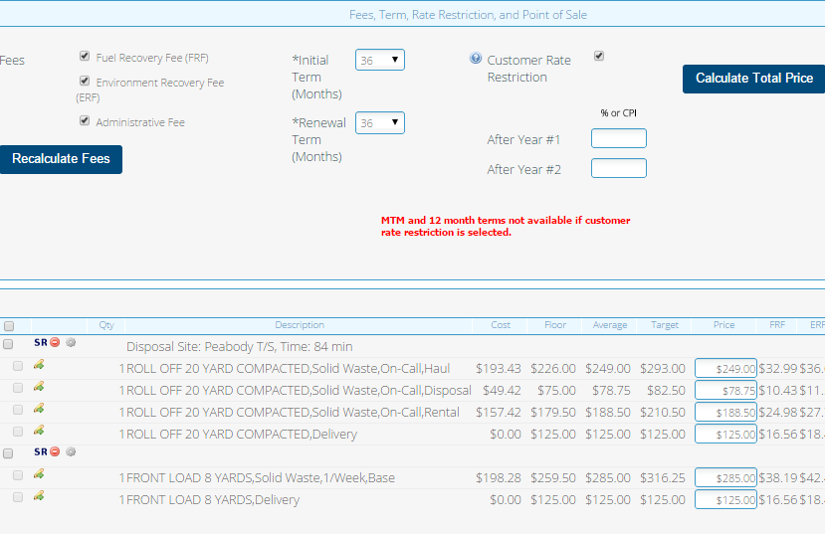

Add note if there are perm & temp containers . “Init/Renewal terms only apply to perm containers”

Add Account Type (Perm/Temp/Seasonal)

# Technical Design

## Referenced Documents

### Usability Standards

### Design Standards

## Process Flow and Logical Model

### Data Flow



### Application flow

#### Sign In Screen

No Changes – should remain the same

#### Start New Quote

Step 1) Start New Quote for Existing Customer – (No Changes )

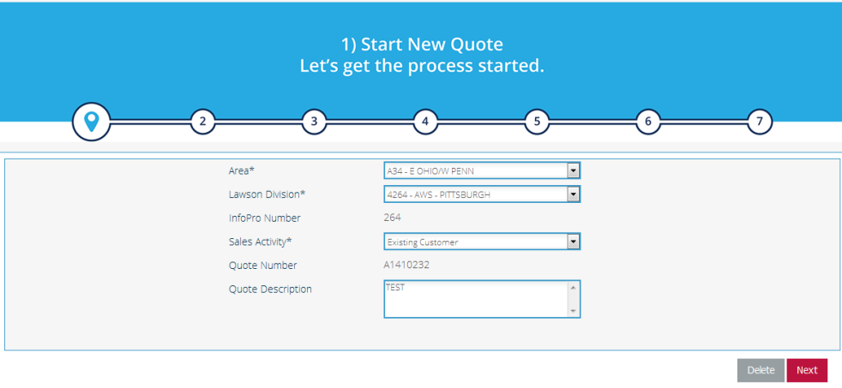

#### Select Existing Customer

Step 2) Enter Customer Site Information (No Changes)

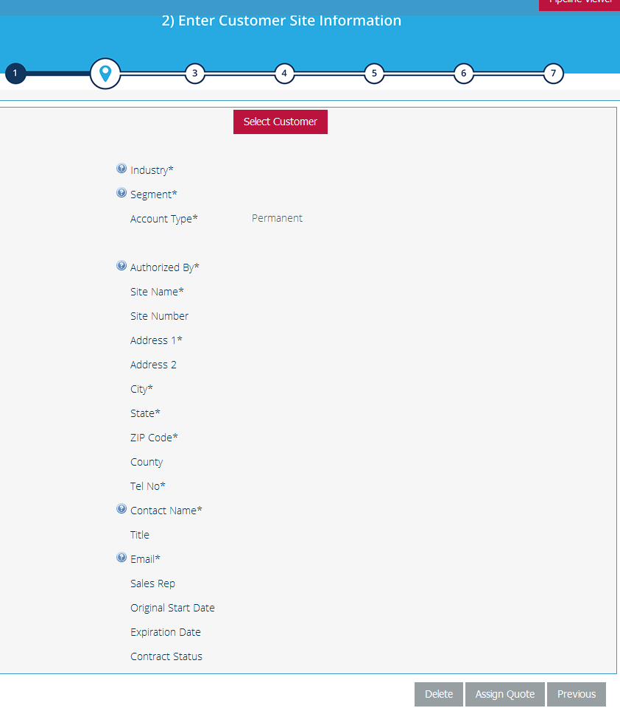

Move to container config screen. Call field Account Type (Put toward top of config screen or new & existing cont)

#### Select Service Offering – View Existing Services

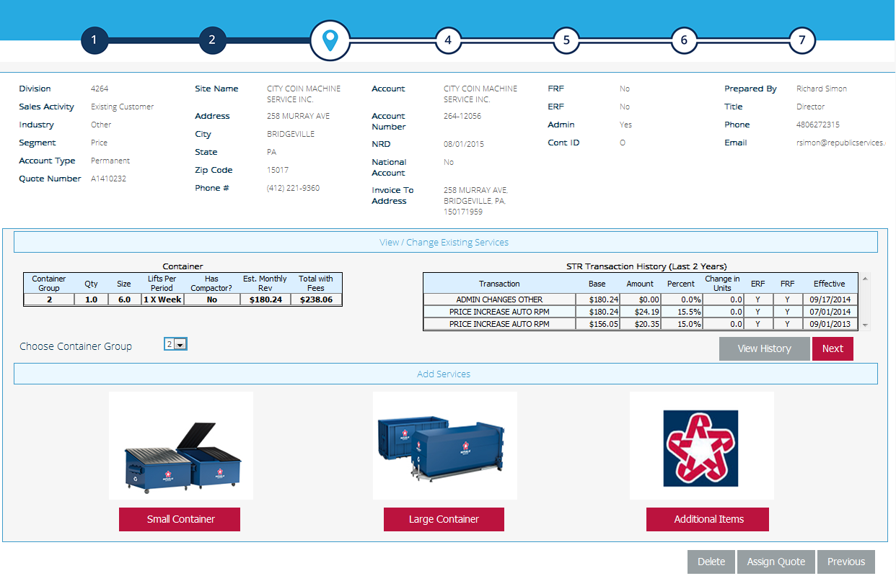

SEE BELOW INSERT B

SEE BELOW INSERT A

INSERT “A”

|  |  |  |  |  |  |  |  |  |  |
| --- | --- | --- | --- | --- | --- | --- | --- | --- | --- |
| **Container** | | | | | | | | | |
| Container  Grp | Qty | Size | Schedule | Compactor | Est Montly  Revenue | Total  Revenue | Avg Hauls  per Month | Avg Tons  per Haul | Avg Service  Min per Haul |
| 1 | 1 | 40 | 1 X Week | N | $1,150 | $1,500 | 4.1 | 5.2 | 82 |
| 2 | 1 | 4 | 1 X Week | N | $350 | $380 | - | - | - |

|  |  |
| --- | --- |
| **Field Sourcing Information** | |
| Container Grp | Small - No Change Large - Pull from account_status_ind.container_grp_nbr |
| Qty | Small - No Change Large - Pull from account_status_ind.container_cnt |
| Size | Small - No Change Large - Pull from account_status_ind.container_size |
| Schedule (lifts /period) | Small - No Change Large - Pull from account_status_ind.?? |
| Compactor | Small - No Change Large - Pull from account_status_ind.has_compactor |
| Estimated Montly Revenue | Small - No Change Large - Calculated |
| Total Revenue | Small - No Change Large - Pull from account_status_ind.container_cnt |
| Avg Hauls per Month | Large Only - small show a "-" |
| Avg Tons per Haul | Large Only - small show a "-" |
| Avg Service Minutes per Haul | Large Only - small show a "-" |

INSERT “B”

|  |  |  |  |  |  |  |  |
| --- | --- | --- | --- | --- | --- | --- | --- |
| **STR Transaction History (Last Two Years)** | | | | | | | |
| Transaction | Core | Amount | Percent | Change  in Units | ERF | FRF | Effective |
| Price Decrease Rollback of PI | $364.59 | -$78.58 | -17.73% | 0 | N | N | 12/1/2004 |
| Price Increase Auto RPM | $443.17 | $89.20 | 25.20% | 0 | N | N | 11/1/2004 |

|  |  |
| --- | --- |
| **Field Sourcing Information** | |
| Transaction | Small - No Change Large - Pull from ??? |
| Core | Small - No Change Large - Pull from ??? |
| Amount | Small - No Change Large - Pull from ??? |
| Percent | Small - No Change Large - Pull from ??? |
| Change in Units | Small - No Change Large - Pull from ??? |
| ERF | Small - No Change Large - Pull from ??? |
| FRF | Small - No Change Large - Pull from ??? |
| Effective | Small - No Change Large - Pull from ??? |

#### Select Service Offering – Service Change

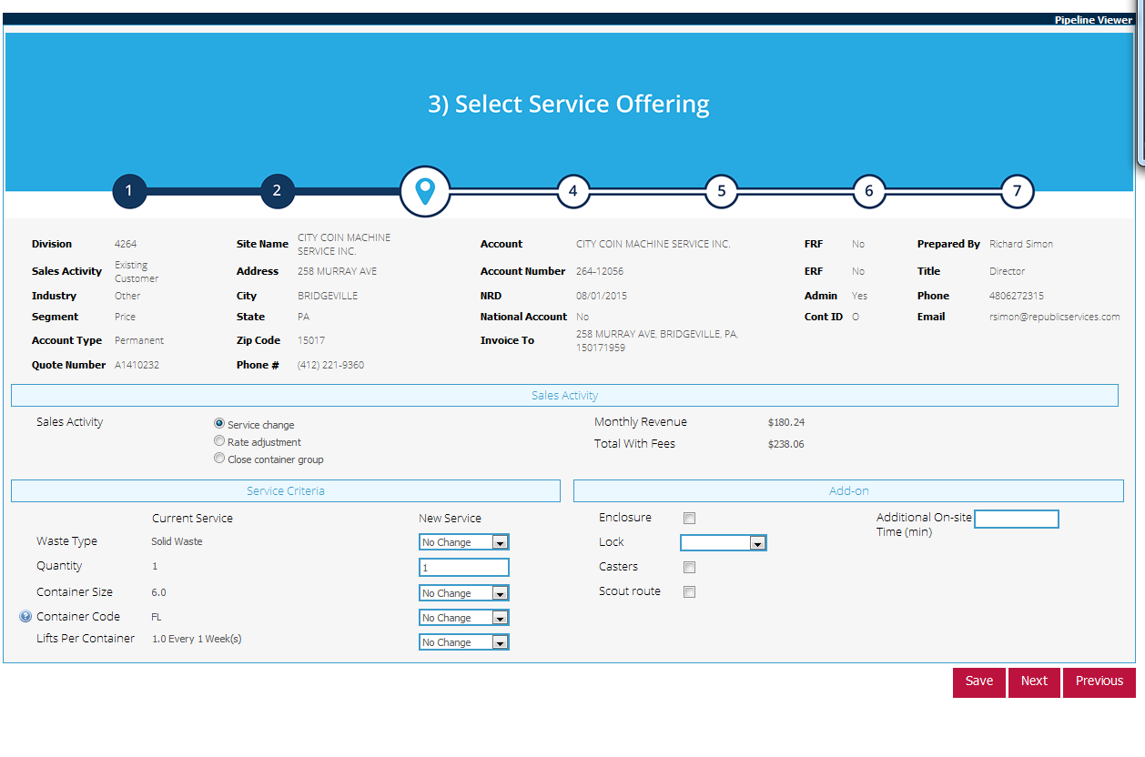

SEE BELOW INSERT C

SEE BELOW INSERT D

INSERT “C”

* Columns in blue will not be shown and are for design specification only
* The following data will be pulled from the account_status_ind table.

|  |  |  |  |  |
| --- | --- | --- | --- | --- |
|  | Current Service | Current Service Notes and source column | New Service | New Service Notes |
| Waste Type | Solid Waste | read only | No Change | drop down defaulted to "No Change" |
| Quantity | 1 | read only | 1 | free form - type integer |
| Container Size | 40 | read only | No Change | drop down defaulted to "No Change" |
| Container Code | RO | read only | No Change | drop down defaulted to "No Change" |
| Account Type | Permenant | read only | Read Only | Can this be changed? No for the time being* |
| Container Type | Open Top | read only | No Change | Cannot be changed (help text to outline process to change container type) |
| Frequency | Scheduled | read only | No Change | drop down defaulted to "No Change" |
| Customer Owned Container | Yes | read only (Yes/No) | Existing value | Show regardless for all container types |
| Compacter Owned | No | read only (Yes/No) | Existing value | Only show if stationary compactor (container type) is selected |
| Hauls per Month (Actual) | 4.2 | read only  float to the tenth all the way to 0.1 | Existing value | If frequency changes allow edit  If scheduled (read only) we calculate  (See Figure 3.1) |
| Disposal Site Name | Imperial L/F | read only | Imperial L/F | Read/Write, use the geo-coded minutes to price  if current site not found, default to 1st site (add help text if site is not found). Use same table, map layout and logic as New Industrial. See Figure 3.2 below. |
| Tons per Haul (Actual) | 5.2 | read only  float to the tenth all the way to 0.1 | 5 | Free form  Get from Account_status_ind table |
| Minutes per Haul (Actual) | 82 | read only  per InfoPro Route Data | 82 | Free form  Get from Account_status_ind table  (if current avg min per haul is > than geo-code minutes) then leave current avg |
| Geo-coded Minutes per Haul | 76 | read only - Bing Maps | 76 | Generated in quote. Allow override values for all three option (desired disposal site, cust site time override, round trip drive time override, disposal time override, adjust total time (read only) |
| UOM | Per Ton | read only | No Change | drop down defaulted to "No Change" |
| Billing Type | Haul + Disposal | read only | No Change | drop down defaulted to "No Change".  See figure 3.3 for Bill Types and associated fields to display for each Bill Type |
| Comp Asset Value | Do Not Display | Can not pull this from InfoPro | Text Field | $ field, Leave blank, optional for rep to enter  Only Display if compactor container type selected (Self-Contained Compactor or Stationary Compactor) |
| One-Time Installation Charge | Do Not Display | Can not pull this from InfoPro | Text Field | $ field, Leave blank, optional for rep to enter  Only Display if compactor container type selected (Self-Contained Compactor or Stationary Compactor) |
|  |  |  |  |  |

Figure 3.1 - Hauls per month calculations if frequency changes

|  |  |  |  |
| --- | --- | --- | --- |
| **Industrial Service Level Changes (Existing)** | | | |
| **Current Status** | **Future Status** | **Calculation Action** | **How** |
| On-Call | Scheduled | "Capture" to perform Calculation – Field Read Only | Future Pick-ups per week times 52/12 |
| On-Call | On-Call | "Capture" to perform Calculation – Field Read Only | Average Hauls per month prior 12 months (actuals) |
| Scheduled | On-Call | User to supply estimate # of hauls per month | Data field open (whole number >= 1) |
| Scheduled | Scheduled | "Capture" to perform Calculation – Field Read Only | Future Pick-ups per week times 52/12 |

Figure 3.2 – New Industrial Disposal Site Map Functionality

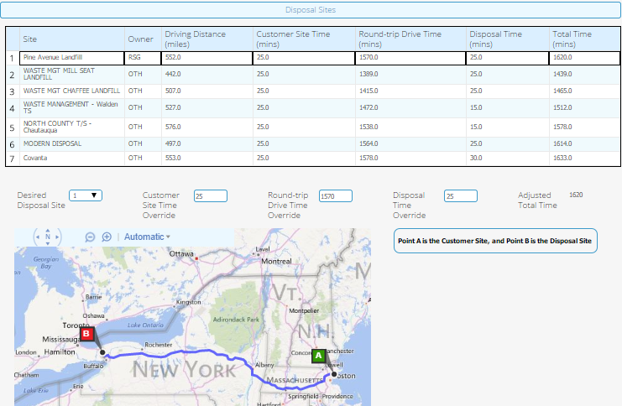

Figure 3.3 – Ton per Haul Fields to display for selected Billing Type

|  |  |  |  |
| --- | --- | --- | --- |
| **Billing Type (Drop Down)** | **Ton / Haul Fields to Inlcude** | | |
| Haul + Disposal | Hauls per Month | Tons per Haul |  |
| Haul + Minimum Tonnage | Hauls per Month | Tons per Haul | Minimum Tons/Haul |
| Flat Rate + Overage | Hauls per Month | Tons Included in Haul Rate |  |

INSERT “D”

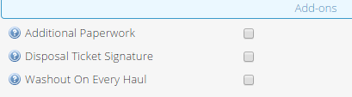

* Columns in blue will not be shown and are for design specification only
* The following data will be pulled from the account_status_ind table.

|  |  |  |  |  |
| --- | --- | --- | --- | --- |
|  | Current Service | Current Service Notes and source column | New Service | New Service Notes |
| Additional Paperwork | Yes | read only (Yes/No) | Existing value | Always show  Checkbox (editable) |
| Disposal Ticket Signature | No | read only (Yes/No) | Existing value | Always show  Checkbox (editable) |
| Washout On Every Haul | No | read only (Yes/No) | Existing value | Always show  Checkbox (editable) |

#### Select Service Offering – Rate Adjustment

This section is all read only once Rate Adjustment (radio button). The rate adjustment will take place on the pricing page

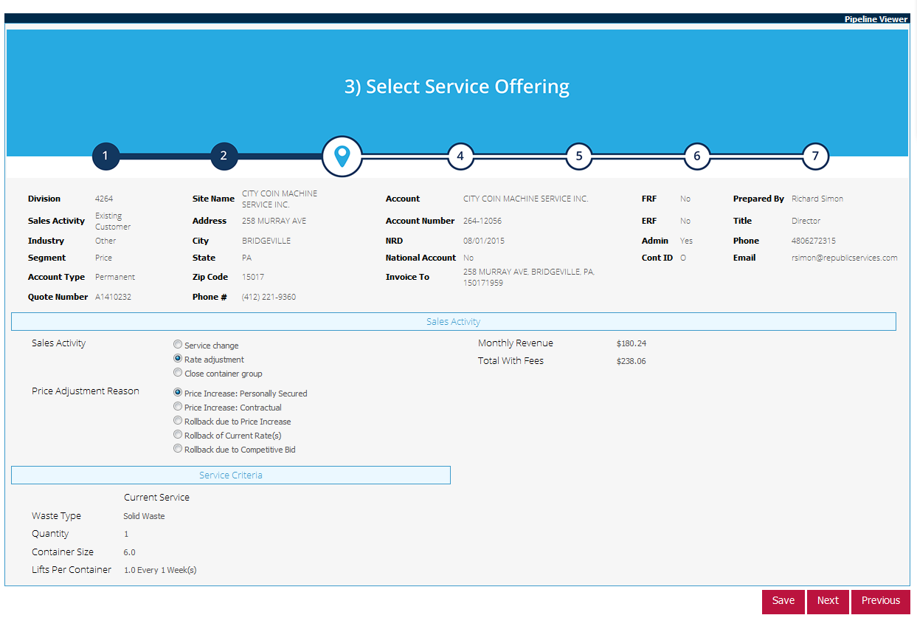

SEE BELOW INSERT E

INSERT “E”

|  |  |  |
| --- | --- | --- |
|  | Current Service | Current Service Notes |
| Waste Type | Solid Waste | read only |
| Quantity | 1 | read only |
| Container Size | 40 | read only |
| Container Code | RO | read only |
| Container Type | Open Top | read only |
| Service Level | Scheduled | read only |
| Customer Owned | No | read only |
| Average Hauls per Month | 4.1 | read only - actual |
| Disposal Site Name | Imperial L/F | read only |
| Average Tons per Haul | 5.2 | read only - actual |
| Average Minutes per Haul | 82 | read only - actual |
| Geo-Coded Minutes per haul | 76 | read only |

#### Select Service Offering – Close Container Group

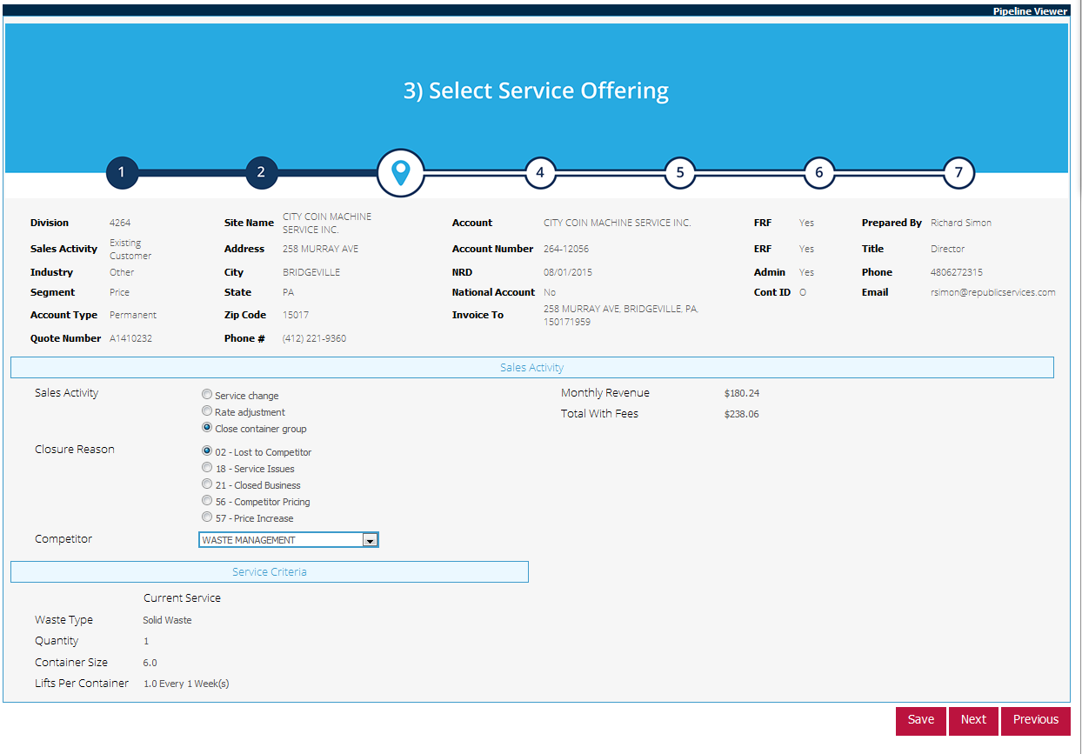

SEE ABOVE INSERT E

#### Generate Docs

#### Finalize Page

How are the transaction reason code calculated? Any updateds needed to the underlying tables?

## Pricing Logic – work in progress

Pricing is categorized into

* Service
* Rental
* Disposal
* One Time Charges
  + Delivery
  + Removal
  + Others…

Categories that identify revenue

•         Haul Codes - 3PF, REC, REG, RE4

•         Disposal Codes - DIS, DSP, DSR, EOF, HHW, OVR, RDS, RMF, VRY

•         Rental Codes – CMR, CPL, DM2, DM3, DM5, DM7, DMR, LEA, MLF, R02, R31, RC3, REC, REG, REN

Other Categories James has (pass through, just on line item grid as FYI, not in monthly totals or proposal or CSA, and are editable on line item grid)

•         Commodity Charge Codes

•         Fee Charge Codes

•         Rebate CC

•         Service

•         Bulk

•         Credits

•         Mainteance –  washouts

•         Site Charge Codes – Liners, etc

•         Other

•         Tax

Whate are the elements of price are we going to support?

If multiple codes do we show them separately and sum up (For example two REGs - my vote yes).

Load every rate/code? No

Topics of Discussion

Service change – can’t designate way to save customer

Price Rollback

Price rollback to PI

Price rollback to competitive bid

4/15 What if we cannot identify the disposal site?

Suggestion –

* Look in sites table first to see if its there
* If it is not default Third Party
* (ensure all Republic sites are in the table first)

Service Calculations

|  |  |
| --- | --- |
| Cost |  |
| Floor | always at their current price |
| Average |  |
| Target | max(floor * (1+ spread),market rate) |
| Price | always set to average |
| ERF |  |
| FRF |  |
| Total |  |

Rental Calculations

|  |  |
| --- | --- |
| Cost |  |
| Floor |  |
| Average |  |
| Target |  |
| Price |  |
| ERF |  |
| FRF |  |
| Total |  |

Disposal Calculations

|  |  |
| --- | --- |
| Cost |  |
| Floor |  |
| Average |  |
| Target |  |
| Price |  |
| ERF |  |
| FRF |  |
| Total |  |

One Time Charges

|  |  |
| --- | --- |
| Cost |  |
| Floor |  |
| Average |  |
| Target |  |
| Price |  |
| ERF |  |
| FRF |  |
| Total |  |

## Data Logic – Work in Progress

### New Required Data

This section will highlight new data fields to be brought in and will need to updated in Mapping Document

New Tables

* account_status_ind – need DDL

Rates should be pulled from rpt_rate_hist

Current filters on the rates? Don’t think so.

Current filters on accounts?

### Logic for producing required data

use DWCORE

-- Step 1: produce Fact_Invoice_Detail temp table -- drop table ##fid

SELECT fid.receipt_nbr,

fid.invoice_detail_pk,

fid.revenue_period_sk,

fid.invoice_dt_sk,

fid.invoice_from_dt_sk,

fid.invoice_to_dt_sk,

fid.invoice_amt,

fid.container_qty,

fid.disposal_qty,

fid.haul_qty,

fid.qty_billed,

fid.disposal_unit_rate_amt,

fid.disposal_ticket_nbr,

fid.invoice_freq_nbr,

fid.disposal_unit_of_measure,

fid.acct_fee_sk,

fid.invoice_note,

fid.corp_hier_sk,

fid.acct_sk,

dcg.Infopro_Div_Nbr,

dcg.Acct_Nbr,

dcg.Site_Nbr,

dcg.Container_Grp_Nbr,

dcg.Orig_Start_Dt,

dcg.is_Container_Owned,

dcg.is_Oncall,

dcg.has_Compactor,

dcg.Container_Cd,

dcg.Container_Nm,

dcg.Excess_Ton_Amt,

s.Employee_SK,

s.Postal_Cd + s.Postal_Cd AS zip,

s.LATITUDE,

s.LONGITUDE,

s.Original_Open_Dt,

s.Contract_Term,

s.Contract_Status,

s.Effective_Dt,

s.Expiration_Dt,

s.Contract_Nbr,

fid.container_grp_sk_2,

fid.charge_cd_sk,

fid.site_sk,

fid.service_cd_sk,

fid.service_dt_sk,

fid.rate_sk,

h.Cur_Div_Nbr,

h.Cur_Infopro_Div_Nbr,

h.Cur_LOB_Category,

dcc.Charge_Cd,

dcc.Charge_Cd_Desc,

dcc.Charge_Method,

dcc.Charge_Method_Desc,

dcc.Charge_Typ,

dcc.Charge_Typ_Desc,

a.Acct_Type

INTO ##fid_t

FROM Fact_Invoice_Detail fid

INNER JOIN Dim_Container_Grp dcg

ON fid.Container_Grp_SK_2 = dcg.Container_Grp_SK

INNER JOIN Dim_Site s

ON fid.Site_SK=s.Site_SK

INNER JOIN Dim_Acct a

ON fid.Acct_SK=a.Acct_SK

INNER JOIN Dim_Corp_Hier h

ON fid.Corp_Hier_SK = h.Corp_Hier_SK

INNER JOIN Dim_Charge_Cd dcc

ON fid.Charge_Cd_SK=dcc.Charge_Cd_SK

WHERE dcg.container_cd IN ( 'IR', 'RO', 'RE', 'RS', 'SC' )

AND dcg.container_size BETWEEN 10 AND 100

AND fid.is_deleted = 0

AND fid.is_updated = 0

AND h.Sub_LOB BETWEEN 100 AND 199 -- 71,040,858 rows in 5m35s; 8m09s (into); 34m09s; 54m15s; 49m43s

select * into ##fid from ##fid_t where revenue_period_sk BETWEEN 201310 AND 201409 -- 18,822,008 rows in 2m40s

drop table ##fid_t

-- Step 2: produce Fact_Service_Detail temp table -- drop table ##fsd

SELECT fsd.load_seq_nbr,

fsd.service_route_minutes,

fsd.service_dump_minutes,

fsd.service_miles_qty,

fsd.is_disposal_allow,

fsd.special_handling_cd AS fsd_special_handling_cd,

fsd.has_compactor AS fsd_has_compactor,

fsd.container_size AS fsd_container_size,

fsd.service_cd_sk,

fsd.service_dt_sk,

fsd.Container_Grp_SK_2,

dcg.has_compactor AS dcg_has_compactor,

dcg.container_size AS dcg_container_size,

dcg.special_handling_cd AS dcg_special_handling_cd,

dcg.Infopro_Div_Nbr,

dcg.Acct_Nbr,

dcg.Site_Nbr,

dcg.Container_Grp_Nbr

INTO ##fsd

FROM fact_service_detail fsd

INNER JOIN dim_corp_hier h

ON fsd.corp_hier_sk = h.corp_hier_sk

INNER JOIN dim_container_grp dcg

ON fsd.container_grp_sk_2 = dcg.container_grp_sk

WHERE fsd.Container_Size BETWEEN 10 AND 100

AND fsd.service_dt_sk BETWEEN 20131001 AND 20140930

AND fsd.is_Updated = 0

AND fsd.is_Deleted = 0

AND dcg.container_cd IN ( 'IR', 'RO', 'RE', 'RS', 'SC' )

AND h.Sub_LOB BETWEEN 100 AND 199 -- 13m44s 5,249,254 rows; 32m30s 5,249,254 rows with joins; 12m4s INTO; 5,053,977 rows in 19m56s; 5,053,977 in 16m16s

-- Step 3: produce Fact_Landfill_Detail temp table -- drop table ##fld

SELECT dcg.infopro_div_nbr,

dcg.Acct_Nbr,

dcg.Site_Nbr,

dcg.Container_Grp_Nbr,

fld.disposal_cd,

fld.disposal_price_cd,

fld.disposal_time_start,

fld.disposal_time_end,

fld.disposal_ticket_nbr,

fld.Process_Dt_SK

INTO ##fld

FROM fact_landfill_detail fld

INNER JOIN dim_container_grp dcg

ON fld.container_grp_sk = dcg.Container_Grp_SK

INNER JOIN dim_corp_hier h

ON fld.corp_hier_sk = h.corp_hier_sk

WHERE fld.Process_Dt_SK BETWEEN 20131001 AND 20140931

AND fld.is_deleted = 0

AND fld.is_updated = 0

AND dcg.container_cd IN ( 'IR', 'RO', 'RE', 'RS', 'SC' )

AND dcg.container_size BETWEEN 10 AND 100 -- 2m24s 4,231,604 rows; 4,231,604 rows in 15s; 4,231,635 rows in 44s

-- Step 4: produce Fact_Sales_Activity temp table

SELECT dcg.infopro_div_nbr,

dcg.acct_nbr,

dcg.site_nbr,

dcg.container_grp_nbr,

fsa.sales_activity_period_sk,

trc.txn_cd,

trc.reason_cd,

trc.txn_reason_desc,

dc.competitor_nm

into ##fsa

FROM dbo.fact_sales_activity AS fsa

INNER JOIN dim_txn_reason_cd AS trc

ON fsa.txn_reason_cd_sk = trc.txn_reason_cd_sk

INNER JOIN dbo.dim_competitor AS dc

ON fsa.competitor_sk = dc.competitor_sk

INNER JOIN dim_container_grp dcg

ON fsa.container_grp_sk=dcg.container_grp_sk

WHERE trc.txn_cd = 1

AND fsa.is_deleted = 0

AND fsa.is_updated = 0

AND dcg.container_cd IN ( 'IR', 'RO', 'RE', 'RS', 'SC' )

AND dcg.container_size BETWEEN 10 AND 100

AND dcg.orig_start_dt BETWEEN '2013-10-01' AND '2014-09-30' -- 340,727 rows in 37s; 4m58s; 340,757 rows in 1m49s

create index ##fid_i ON ##fid(Infopro_Div_Nbr,acct_nbr,Site_Nbr,Container_Grp_Nbr,Invoice_Dt_SK,Disposal_Ticket_Nbr,Service_Dt_SK,Service_Cd_SK) -- 19s

create index ##fld_i ON ##fld(Infopro_Div_Nbr,Acct_Nbr,Site_Nbr,Container_Grp_Nbr,process_dt_sk,Disposal_Ticket_Nbr) -- 3s

create index ##fsd_i ON ##fsd(infopro_div_nbr,Acct_Nbr,Site_Nbr,Container_Grp_Nbr,Service_Dt_SK,Service_Cd_SK) -- 3s

create index ##fsa_i ON ##fsa(Sales_Activity_Period_SK,Infopro_Div_Nbr,Acct_Nbr,Site_Nbr,Container_Grp_Nbr) -- 1s

DECLARE @account_status_ind TABLE(

);

INSERT INTO @account_status_ind

select fid.Cur_Div_Nbr,

fid.Cur_Infopro_Div_Nbr,

fid.Acct_Nbr,

fid.Site_Nbr,

fid.zip,

fid.LATITUDE,

fid.LONGITUDE,

fid.Container_Grp_Nbr,

fid.is_Container_Owned,

fid.is_Oncall,

fid.Charge_Cd,

fid.Charge_Cd_Desc,

fid.receipt_nbr,

Row_number() OVER (partition BY fid.invoice_detail_pk ORDER BY fsd.load_seq_nbr) AS row1,

fid.charge_method,

fid.charge_method_desc,

fid.charge_typ,

fid.charge_typ_desc,

fld.disposal_cd,

fld.disposal_price_cd,

fld.disposal_time_start,

fld.disposal_time_end,

fid.[revenue_period_sk],

fid.[invoice_dt_sk],

fid.[invoice_from_dt_sk],

fid.[invoice_to_dt_sk],

fid.[invoice_amt],

fid.[container_qty],

fid.[disposal_qty],

fid.[haul_qty],

fid.[qty_billed],

fid.[disposal_unit_rate_amt],

fid.[disposal_ticket_nbr],

fid.[invoice_freq_nbr],

fid.[disposal_unit_of_measure],

fsd.service_route_minutes,

fsd.service_dump_minutes,

fsd.service_miles_qty,

fsd.is_disposal_allow,

fid.orig_start_dt,

fsa.txn_cd,

fsa.reason_cd,

fsa.txn_reason_desc,

fsa.competitor_nm,

CASE

WHEN Datediff(m, fid.orig_start_dt, CONVERT(DATETIME, CONVERT(VARCHAR(8), fid.invoice_dt_sk), 112)) <= 6 THEN 1

ELSE 0

END AS new_customer_cg_flag,

COALESCE(fsd.fsd_special_handling_cd, fsd.dcg_special_handling_cd) AS special_handling_cd,

CASE

WHEN fsd.fsd_special_handling_cd IN ( 'A', 'D', 'S', 'X', '6', '4' ) THEN 1

ELSE 0

END AS special_waste,

COALESCE(fsd.fsd_has_compactor, fsd.dcg_has_compactor) AS has_compactor,

COALESCE(fsd.fsd_container_size, fsd.dcg_container_size) AS container_size,

fid.Container_Cd,

fid.Container_Nm,

fid.Cur_LOB_Category,

CASE

WHEN fid.Acct_Type IN ( 'P', 'B', 'C', 'E', 'L' ) THEN 'Permanent'

WHEN fid.Acct_Type = ( 'S' ) THEN 'Seasonal'

WHEN fid.Acct_Type = ( 'I' ) THEN 'Intercompany'

WHEN fid.Acct_Type IN ( 'T', 'X' ) THEN 'Temporary'

ELSE fid.Acct_Type

END AS acct_type,

fid.Excess_Ton_Amt,

drh.Rate_Eff_Dt,

daf.Fee_Type,

daf.Fee_Type_Desc,

daf.is_Locked,

CASE

WHEN fid.Acct_Fee_SK > 0 THEN 1

ELSE 0

END AS is_fee,

CASE

WHEN fid.Invoice_Note = '@ERFONFRF@' THEN 1

ELSE 0

END AS is_erf_on_frf,

fid.Original_Open_Dt AS site_open_dt,

fid.Contract_Term,

fid.Contract_Status,

fid.Effective_Dt AS contract_start_dt,

fid.Expiration_Dt AS contract_end_dt,

fid.Contract_Nbr,

e.Employee_EIN

into ##result

from ##fid fid

LEFT OUTER JOIN ##fld fld

ON fid.Infopro_Div_Nbr=fld.Infopro_Div_Nbr

AND fid.acct_nbr=fld.Acct_Nbr

AND fid.Site_Nbr=fld.Site_Nbr

AND fid.Container_Grp_Nbr=fld.Container_Grp_Nbr

AND fid.Invoice_Dt_SK=fld.process_dt_sk

AND fid.Disposal_Ticket_Nbr=fld.Disposal_Ticket_Nbr

LEFT OUTER JOIN ##fsd fsd

ON fid.Infopro_Div_Nbr=fsd.infopro_div_nbr

AND fid.Acct_Nbr=fsd.Acct_Nbr

AND fid.Site_Nbr=fsd.Site_Nbr

AND fid.Container_Grp_Nbr=fsd.Container_Grp_Nbr

AND fid.Service_Dt_SK=fsd.Service_Dt_SK

AND fid.Service_Cd_SK=fsd.Service_Cd_SK -- type 1 dimension, so this is ok

LEFT OUTER JOIN ##fsa fsa

ON DATEPART(YEAR,fid.Orig_Start_Dt)*100 + DATEPART(MONTH,fid.Orig_Start_Dt)=fsa.Sales_Activity_Period_SK

AND fid.Infopro_Div_Nbr=fsa.Infopro_Div_Nbr

AND fid.Acct_Nbr=fsa.Acct_Nbr

AND fid.Site_Nbr=fsa.Site_Nbr

AND fid.Container_Grp_Nbr=fsa.Container_Grp_Nbr

LEFT OUTER JOIN dim_rate_hist drh

ON fid.Rate_SK=drh.rate_sk

LEFT OUTER JOIN dim_acct_fee daf

ON fid.Acct_Fee_SK=daf.Acct_Fee_SK

LEFT OUTER JOIN dbo.dim_employee e

ON fid.Employee_SK=e.Employee_SK -- 21,353,629 rows in 8m22s

DELETE FROM ##result WHEre row1!=1 -- get rid of duplicates

--select count(*) from ##result where row1=1 -- 18,822,008 rows

### SSIS Packages

An SSIS package must be developed to produce the account_status_ind table, update certain columns within it from the (TBD) table, and produce a CSV output file to send to Capture. Its flow is as follows:

The “Process Report XLS File” Data Flow Task looks like:

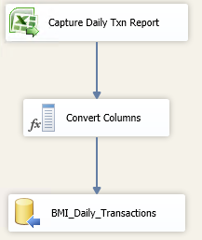

## Record Counts

Record count of account_status_ind from 20131001 to 20140930 is approximately 19 million.

## Index on the Tables

TBD

## Batch Job Schedule and Dependency

TBD

## Data Sources & Mapping

For detailed mapping information, please refer to the [Enterprise Mapping Document](http://itpmo-2010projects/BI%20Program%20Strategy/3.0%20Design/Mapping/Enterprise%20Mapping%20Document.xls).

## Physical Data Model

See the [Enterprise Mapping Document](http://itpmo-2010projects/BI%20Program%20Strategy/3.0%20Design/Mapping/Enterprise%20Mapping%20Document.xls) for column and data type details. Also see the test tables created in devbmisql01.BMIDM

Preliminary account_status_ind table structure is as follows

James

## Framework Model

No Changes.

## Validation/Error Handling

No Changes.

## Interfaces

Not Applicable.

# Downstream Impacts

## InfoPro Upload

## TIBCO/BI Reporting

TBD

# Technical Architecture

## Infrastructure Considerations

No changes to infrastructure.

## Data Retention

No changes to data retention.

## High Availability

Not Applicable.

## Backup, Rollback and Recover

No changes to backup and recovery procedures.

# Other Design Specifications

## Build/Configure Standards

Reference Aldon procedures for BI.

## Policies and Procedures

Conforms to all published IT policies and procedures.

## Security Design

### New or Existing Security

No Changes.

### Hierarchal Data Access

No Changes.

### Infrastructure

No Changes.

## Environmental

No Additional environmental requirements.

# Appendix

## Original prototype query (James Shrenk)

SELECT a.*

FROM (SELECT b.cur_div_nbr,

b.cur_infopro_div_nbr,

c.acct_nbr,

f.site_nbr,

f.postal_cd AS zip,

d.container_grp_nbr,

d.is_container_owned,

d.is_oncall,

e.charge_cd,

e.charge_cd_desc,

a.receipt_nbr,

Row_number()

OVER (

partition BY a.invoice_detail_pk

ORDER BY h.load_seq_nbr) AS row1,

e.charge_method,

e.charge_method_desc,

e.charge_typ,

e.charge_typ_desc,

g.disposal_cd,

g.disposal_price_cd,

g.disposal_time_start,

g.disposal_time_end,

a.[revenue_period_sk],

a.[invoice_dt_sk],

a.[invoice_from_dt_sk],

a.[invoice_to_dt_sk],

a.[invoice_amt],

a.[container_qty],

a.[disposal_qty],

a.[haul_qty],

a.[qty_billed],

a.[disposal_unit_rate_amt],

a.[disposal_ticket_nbr],

a.[invoice_freq_nbr],

a.[disposal_unit_of_measure],

h.service_route_minutes,

h.service_dump_minutes,

h.service_miles_qty,

h.is_disposal_allow,

d.orig_start_dt,

j.txn_cd,

j.reason_cd,

j.txn_reason_desc,

j.competitor_nm,

CASE

WHEN Datediff(m, d.orig_start_dt, CONVERT(DATETIME, CONVERT(VARCHAR(8), a.invoice_dt_sk), 112)) <= 6 THEN 1

ELSE 0

END AS new_customer_cg_flag,

CASE

WHEN h.[special_handling_cd] IS NULL THEN d.special_handling_cd

ELSE h.special_handling_cd

END AS special_handling_cd,

CASE

WHEN h.special_handling_cd IN ( 'A', 'D', 'S', 'X',

'6', '4' ) THEN 1

ELSE 0

END AS special_waste,

CASE

WHEN h.[has_compactor] IS NULL THEN d.has_compactor

ELSE h.has_compactor

END AS has_compactor,

CASE

WHEN h.[container_size] IS NULL THEN d.container_size

ELSE h.container_size

END AS container_size,

d.container_cd,

d.container_nm,

b.cur_lob_category,

CASE

WHEN c.acct_type IN ( 'P', 'B', 'C', 'E', 'L' ) THEN 'Permanent'

WHEN c .acct_type = ( 'S' ) THEN 'Seasonal'

WHEN c.acct_type = ( 'I' ) THEN 'Intercompany'

WHEN c.acct_type IN ( 'T', 'X' ) THEN 'Temporary'

ELSE c.acct_type

END AS acct_type,

d.excess_ton_amt,

k.rate_eff_dt,

m.fee_type,

m.fee_type_desc,

m.is_locked,

CASE

WHEN a.acct_fee_sk > 0 THEN 1

ELSE 0

END AS is_fee,

CASE

WHEN a.invoice_note = '@ERFONFRF@' THEN 1

ELSE 0

END AS is_erf_on_frf,

f.original_open_dt AS site_open_dt,

f.contract_term,

f.contract_status,

f.effective_dt AS contract_start_dt,

f.expiration_dt AS contract_end_dt,

f.contract_nbr,

n.employee_ein

FROM [dbo].[fact_invoice_detail] AS a

INNER JOIN dbo.dim_corp_hier AS b

ON a.corp_hier_sk = b.corp_hier_sk

INNER JOIN dbo.dim_acct AS c

ON a.acct_sk = c.acct_sk

INNER JOIN dbo.dim_container_grp AS d

ON a.container_grp_sk_2 = d.container_grp_sk_2

INNER JOIN dbo.dim_charge_cd AS e

ON a.charge_cd_sk = e.charge_cd_sk

INNER JOIN dbo.dim_site AS f

ON a.site_sk = f.site_sk

LEFT JOIN dbo.fact_landfill_detail AS g

ON a.acct_sk = g.acct_sk

AND a.disposal_ticket_nbr = g.disposal_ticket_nbr

AND a.site_sk = g.site_sk

AND a.container_grp_sk_2 = g.container_grp_sk_2

AND a.invoice_dt_sk = g.process_dt_sk

LEFT JOIN dbo.fact_service_detail AS h

ON a.container_grp_sk_2 = h.container_grp_sk_2

AND a.service_cd_sk = h.service_cd_sk

AND a.service_dt_sk = h.service_dt_sk

INNER JOIN dbo.dim_service_cd AS i

ON a.service_cd_sk = i.service_cd_sk

LEFT JOIN (SELECT a.acct_sk,

a.site_sk,

a.container_grp_sk,

a.sales_activity_period_sk,

b.txn_cd,

b.reason_cd,

b.txn_reason_desc,

c.competitor_nm

FROM dbo.fact_sales_activity AS a

INNER JOIN dbo.dim_txn_reason_cd AS b

ON a .txn_reason_cd_sk = b.txn_reason_cd_sk

INNER JOIN dbo.dim_competitor AS c

ON a.competitor_sk = c.competitor_sk

WHERE b.txn_cd = 1

AND a.is_deleted = 0

AND a.is_updated = 0

AND a.is_merged = 0

AND a.is_split = 0) AS j

ON Datepart (year, d.orig_start_dt) * 100 + Datepart(month, d.orig_start_dt) = j.sales_activity_period_sk

AND a.acct_sk = j.acct_sk

AND a.site_sk = j.site_sk

AND a.container_grp_sk_2 = j.container_grp_sk

LEFT JOIN dbo.dim_rate_hist AS k

ON a.rate_sk = k.rate_sk

LEFT JOIN dbo.dim_acct_fee AS m

ON a.acct_fee_sk = m.acct_fee_sk

LEFT JOIN dbo.dim_employee AS n

ON f.employee_sk = n.employee_sk

WHERE 1 = 1

AND sub_lob BETWEEN 100 AND 199

AND a.is_deleted = 0

AND a.is_updated = 0

AND a.is_split = 0

AND a.is_merged = 0

AND c.is_franchise = 0

AND c.is_national_account = 0

AND d.container_cd IN ( 'IR', 'RO', 'RE', 'RS', 'SC' )

AND d.container_size BETWEEN 10 AND 100

AND a.revenue_period_sk BETWEEN 201310 AND 201409) AS a

WHERE a.row1 = 1